**Abstract**

Vehicle Management is an application where a customer Details are stored in order to choose cars, bikes and commercial vehicles for travel within the city. The data which is stored here, further used to remind them if any offers are provided during the seasons and any updates regarding vehicles are sent to them in the form of messages and mails.

**Vehicle Management System Using Salesforce**

### Introduction:

Are you new to Salesforce? Not sure exactly what it is, or how to use it? Don’t know where you should start on your learning journey? If you’ve answered yes to any of these questions, then you’re in the right place. This module is for you.

Welcome to Salesforce! Salesforce is game-changing technology, with a host of

productivity-boosting features, that will help you sell smarter and faster. As you work toward your badge for this module, we’ll take you through these features and answer the question, “What is Salesforce, anyway?”

# **What Is Salesforce?**

Salesforce is your customer success platform, designed to help you sell, service, market, analyze, and connect with your customers.

Salesforce has everything you need to run your business from anywhere. Using standard products and features, you can manage relationships with prospects and customers, collaborate and engage with employees and partners, and store your data securely in the cloud.

Creating Developer Account

**Creating a developer org in salesforce:**

1.Go to developers.salesforce.com/

2.Click on sign up.

3.On the sign up form, enter the following details :

 a. First name & Last name

 b. Email

 c. Role : Developer

 d. Company : College Name

 e. County : India

 f. Postal Code : pin code

 g. Username : should be a combination of your name and company

 This need not be an actual email id, you can give anything in the format : [username@organization.com](mailto:username@organization.com)

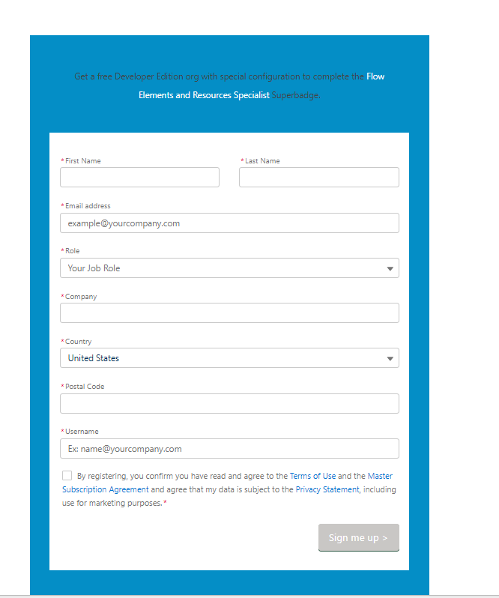

**Object**

Salesforce objects are database tables that permit you to store data that is specific to an organization.

**Salesforce objects are of two types:** Standard Objects: Standard objects are the kind of objects that are provided by salesforce.com such as users, contracts, reports, dashboards, etc.

**Standard Objects:**Account, Contact, Opportunity.

**Custom objects:** Vehicle, Driver, Traveler.

**To Create An Object**

For this Vehicle Management we need to create three custom objects i.e. Vehicles, Driver and Traveler.

**The below steps will assist you in creating those objects.**

* Click on the gear icon and then select Setup.
* Click on the object manager tab just beside the home tab.
* After the above steps, have a look on the extreme right you will find a Create Dropdown click on that and select Custom Object.

**On the Custom Object Definition page, create the object as follows:**

* **Label**: Vehicle
* **Plural Label**: Vehicles
* **Record Name**: Vehicle Name
* Check the Allow Reports checkbox
* Check the Allow Search checkbox
* Click Save.
* Now create a custom tab. Click the Home tab, enter Tabs in Quick Find and select Tabs.
* Under Custom Object Tabs, click New.
* For Object, select Vehicle.
* For Tab Style, select any icon.
* Leave all defaults as is. Click Next, Next, and Save.

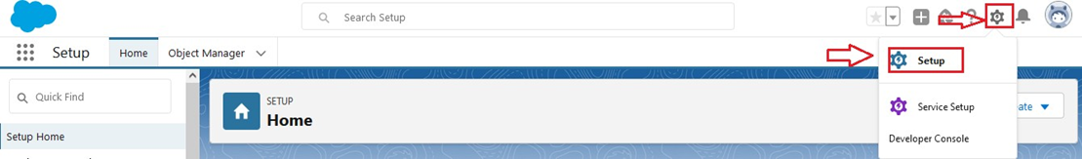

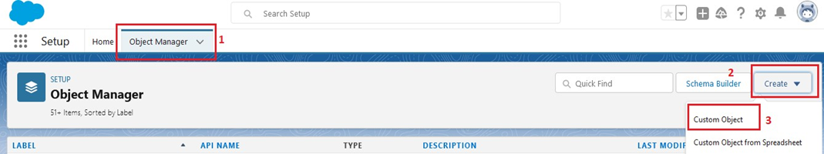

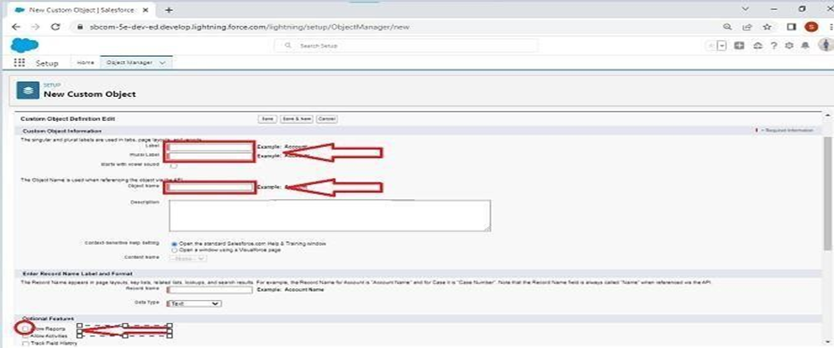

**To Create The Driver Object**

For this Vehicle Management we need to create three custom objects i.e. Vehicles, Driver and Traveler.

**The below steps will assist you in creating those objects**.

* Click on the gear icon and then select Setup.
* Click on the object manager tab just beside the home tab.
* After the above steps, have a look on the extreme right you will find a Create Dropdown click on that and select Custom Object.

**On the Custom Object Definition page, create the object as follows:**

* Label: Driver
* Plural Label: Drivers
* Record Name: Driver Name
* Check the Allow Reports checkbox
* Check the Allow Search checkbox
* Click Save.
* Now create a custom tab. Click the Home tab, enter Tabs in Quick Find and select Tabs.
* Under Custom Object Tabs, click New.
* For Object, select Driver.
* For Tab Style, select any icon.
* Leave all defaults as is. Click Next, Next, and Save.







**To Create The Traveler Object**

For this Vehicle Management we need to create three custom objects i.e. Vehicles, Driver and Traveler.

**The below steps will assist you in creating those objects.**

* Click on the gear icon and then select Setup.
* Click on the object manager tab just beside the home tab.
* After the above steps, have a look on the extreme right you will find a Create Dropdown click on that and select Custom Object.

**On the Custom Object Definition page, create the object as follows**:

* **Label**: Traveler
* **Plural Label**: Travelers
* **Record Name**: Traveler Name
* Check the Allow Reports checkbox
* Check the Allow Search checkbox
* Click Save.
* Now create a custom tab. Click the Home tab, enter Tabs in Quick Find and select Tabs.
* Under Custom Object Tabs, click New.
* For Object, select Traveler.
* For Tab Style, select any icon.
* Leave all defaults as is. Click Next, Next, and Save.







**Fields And Relationship**

An object relationship in Salesforce is a two-way association between two objects. Relationships are created by creating custom relationship fields on an object. This is done so that when users view records, they can also see and access related data.

**Creation Of Fields**

Fields in Vehicles objects follow below data types:

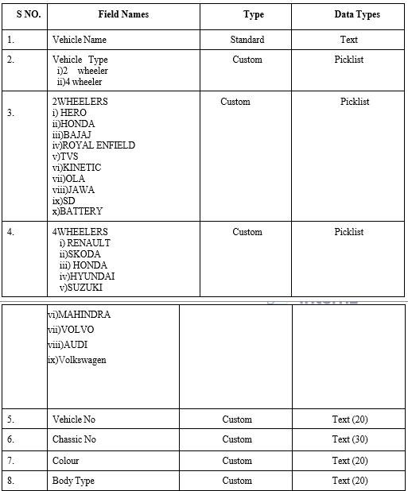

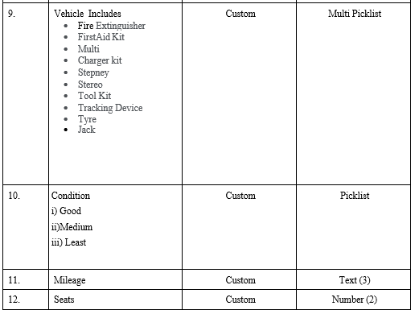

The below steps will assist you in creating Fields.

1.Click on the gear icon and then select Setup.

2.Click on the object manager tab just beside the home tab.

3.Search object (Vehicle) in quick find box.

4.Click fields & relationships and click new

5.Select any data type click next

6.Enter field label name and select next, next, and Save.

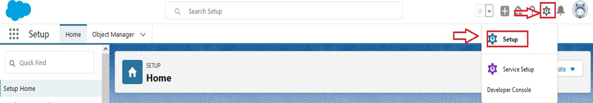

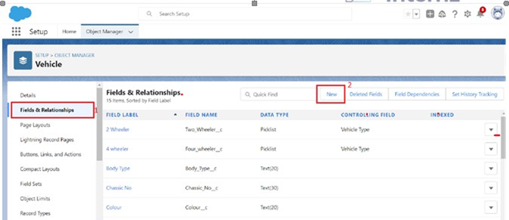

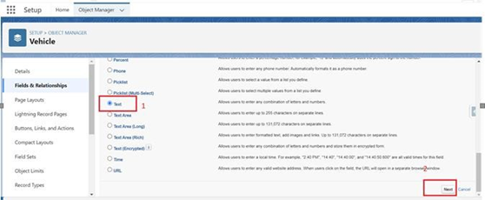

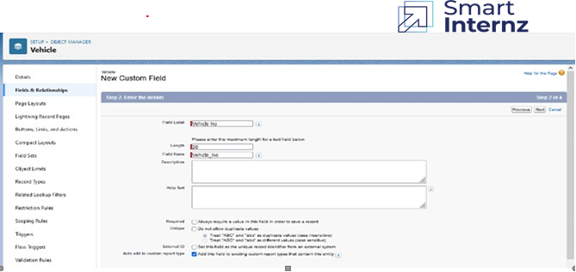

**Fields In Vehicle Object**

Create a dependency between these two picklists, so that when a Vehicle type is selected,

only respective 2Wheeler Brands are available in the 2Wheeler field, similarly for4Wheelers.

**The below steps will assist you in creating Field Dependencies.**

1. Click on the gear icon and then select Setup.
2. Click on the object manager tab just beside the home tab.
3. After the above steps, Select Vehicles Object
4. Now Select Fields and relationships from setup menu of the vehicle object.
5. Click Field Dependencies.
6. Click New.
7. Select Vehicle Type as the Controlling Field and select 2wheelers as the Dependent Field.
8. Click Continue.
9. Select the appropriate 2 wheelers Brands in each column by double-clicking them.

2 WHEELERS :

i) HERO

ii)HONDA

iii)BAJAJ

iv)ROYAL ENFIELD

v)  TVS

vi)KINETIC

vii)OLA

viii)JAWA

ix)SD

x)BATTERY

1. Click Include Values.
2. Click Preview, then test the dependency by selecting different Vehicle Type and viewing the different Vehicles available     for Vehicle Type.
3. Click Close to close the preview window.
4. Click Save.

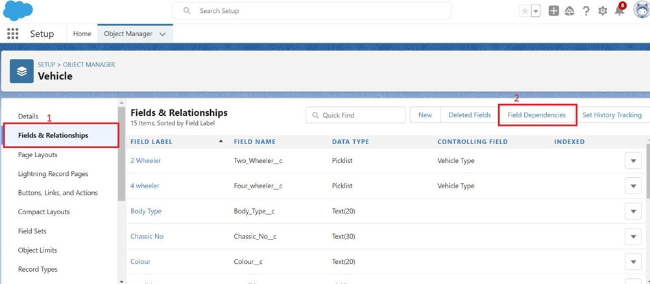

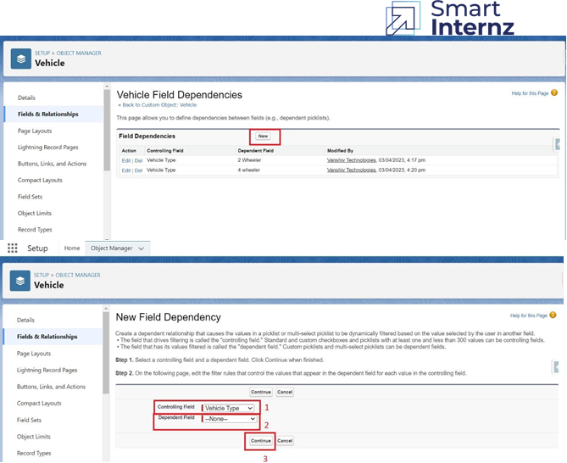

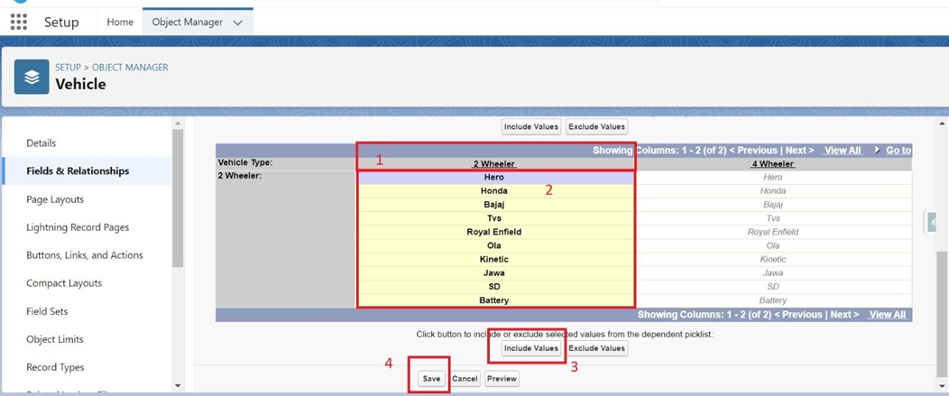

**Follow same steps for 4wheelers also**

1.Vehicle Type as the Controlling Field and select 4wheelers as the Dependent Field.

2.Click Continue.

3.Select the appropriate 4wheelers Brands in each column by double-clicking them.

4.4WHEELERS :

i)RENAULT

ii)SKODA

iii)HONDA

iv)HYUNDAI

v)SUZUKI

vi)MAHINDRA

vii) VOLKSWAGEN

viii) BENZ

ix)AUDI

x)VOLVO

5.Click Include Values.

6.Click Preview, then test the dependency by selecting different Vehicle Type and viewing the different Vehicles     available for Vehicle Type.

7.Click Close to close the preview window.

8.Click Save.

**Fields In Driver Objects Follow Below Data Types:**

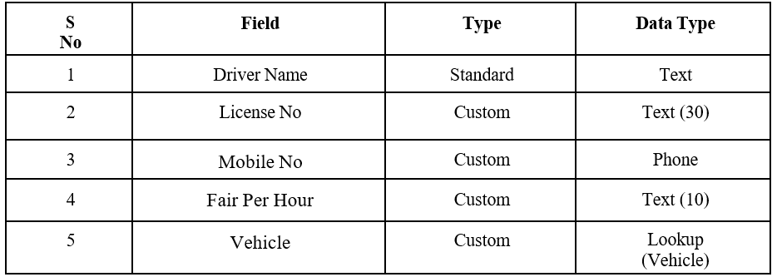

**Create a Lookup fields**

1.Click fields & relationships and click new

2.Select Lookup relationship & click next

3.Choose the related object as Vehicle & click next

4.Give the field label & click next, next, next and Save.

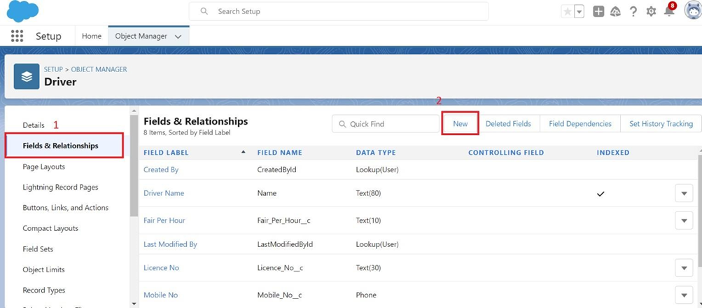

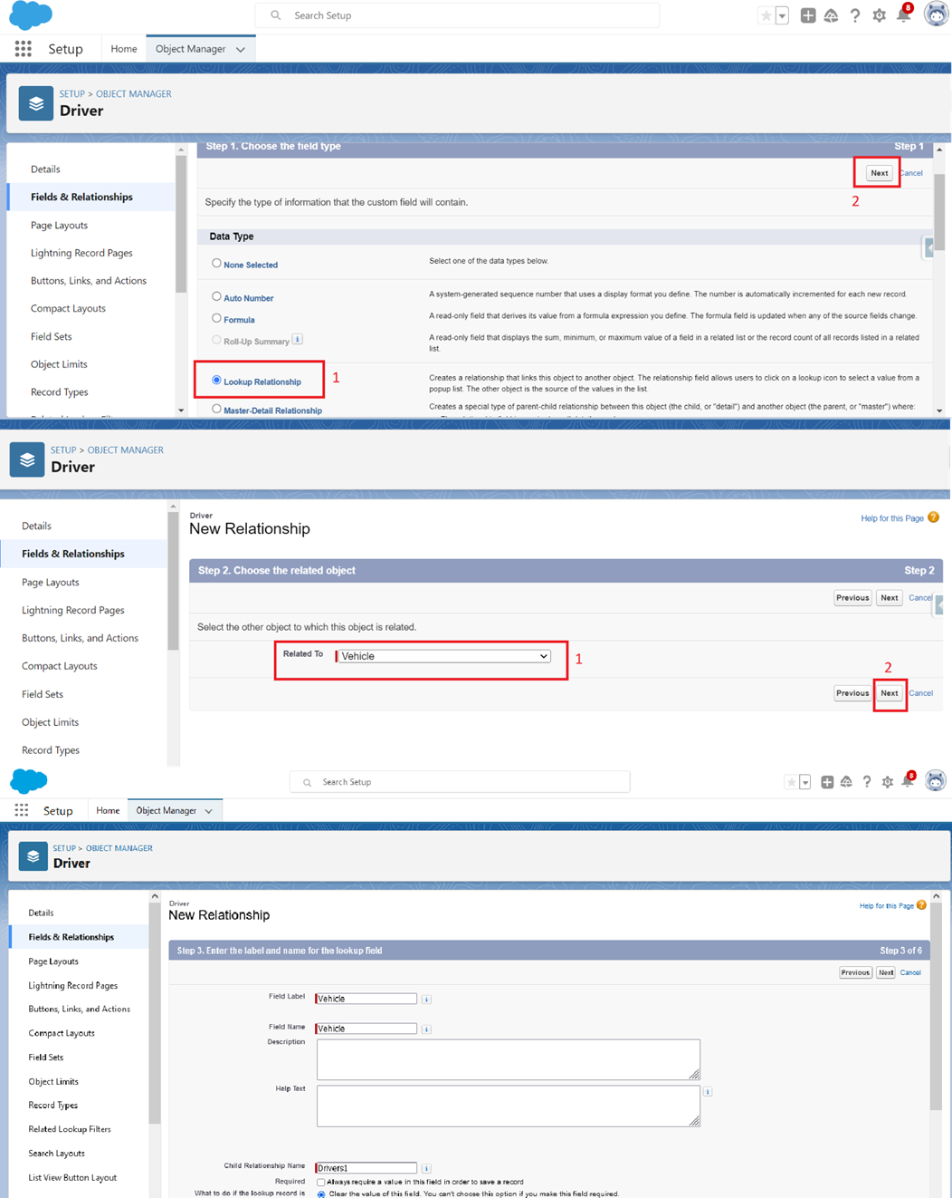

### Fields In Traveler Objects Follow Below Data Types

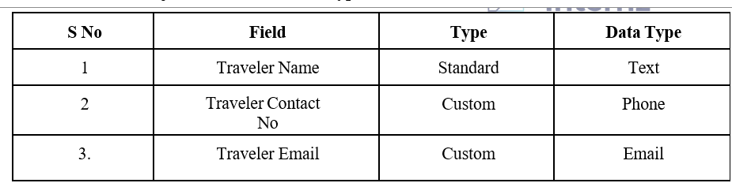

### Fields In Opportunity Objects Follow Below Data Types

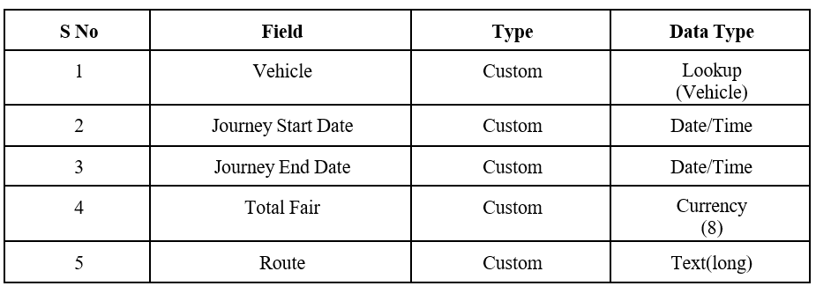

Page Layout Setup

**Organize Opportunity Layout**

**Organize Opportunity layout:**

1. Click on the gear icon and then select Setup.
2. Click on the object manager tab just beside the home tab.
3. Search in quick find (Opportunity) & select Opportunity.
4. Click on page layout and you can add or remove fields by drag & drop

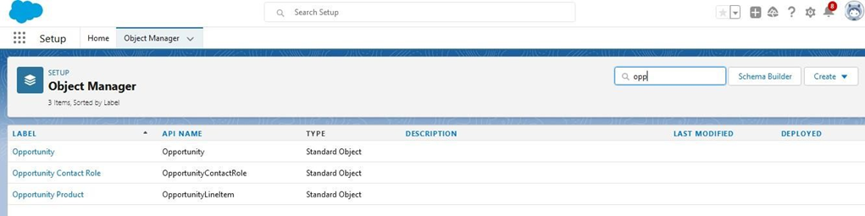

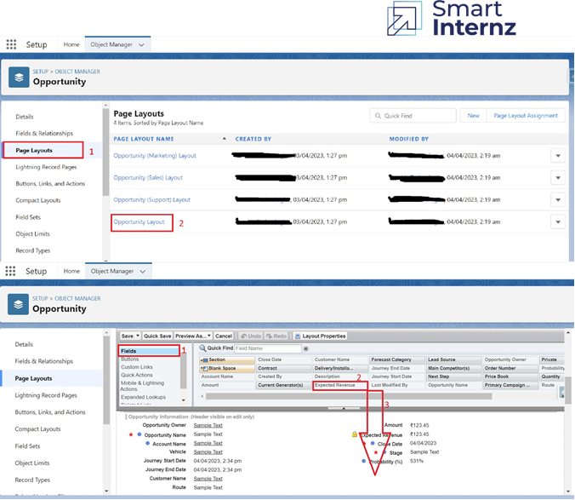

You can setup layout for all other objects and lay

### Lightning App

**Create The Vehicle Management App:**

1.From Setup, enter App Manager in the Quick Find and select App Manager.

2.Click New Lightning App. Enter Vehicle Management as the App Name, then click Next

3.Under App Options, leave the default selections and click Next.

4.Under Utility Items, leave as is and click Next.

5.From Available Items, select Accounts, Contacts, Opportunities, Vehicle, Driver, Travelers, Reports, and   Dashboards and move them to Selected Items. Click Next.

6.From Available Profiles, select System Administrator and move it to Selected Profiles. Click Save & Finish.

7.To verify your changes, click the App Launcher, type Vehicle Management and select the Vehicle Management app.

Note:

1.App Launcher-Displays available apps.

2.App Name-Displays the current selected app.

3.Navigation menu-Displays the tabs available inside the app.

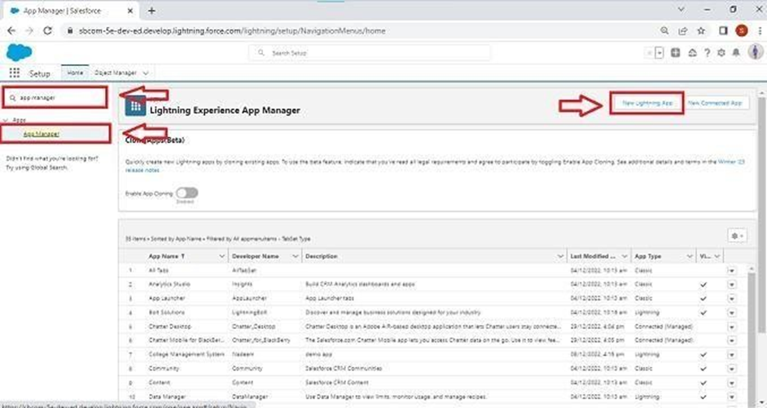

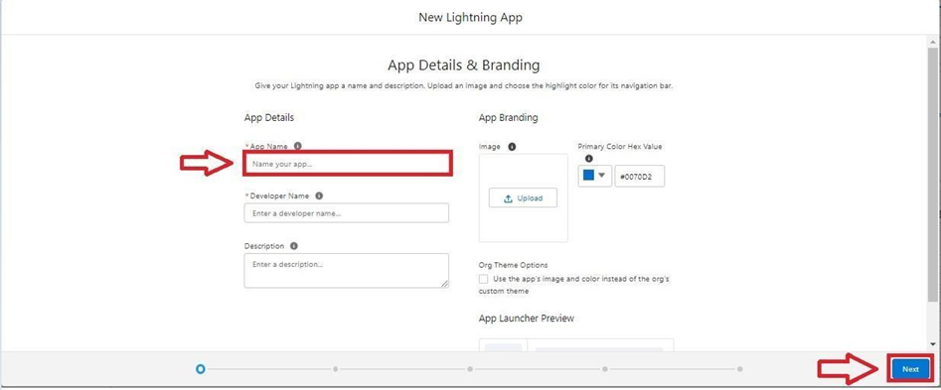

To Add Navigation Items:

Select the items from the search bar and move it using the arrow button ? Next

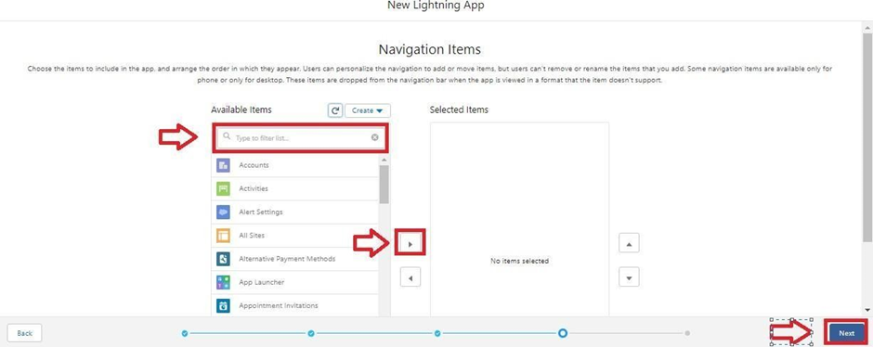

To Add User Profiles:

Search profiles in search bar ? click on the arrow button ? save & finish.

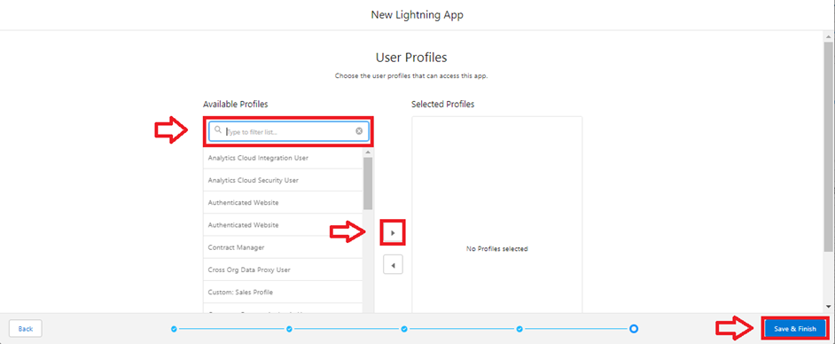

**Profile**

A profile is a group/collection of settings and permissions that define what a user can do in salesforce. A profile controls “Object permissions, Field permissions, User permissions, Tab settings, App settings, Apex class access, Visualforce page access, Page layouts, Record Types, Login hours & Login IP ranges

**Creating A Profile**

**Creating a Profile:** Now create a Vehicle Manager profile and set it’s object permissions.

**Creating a Profile:**

Now create a Vehicle Manager profile and set its object permissions.

1.From Setup enter Profiles in the Quick Find box, and select Profiles.

2.From the list of profiles, find Standard User.

3.Click Clone.

4.For Profile Name, enter Vehicle Manager.

5.Click Save.

6.While still on the Vehicle Manager Profile page, then click Edit.

7.Scroll down to Custom Object Permissions and give access for

Create, Read, Edit, and Delete, View all and modify all for Vehicle object Driver object and Traveler object.

To create a new profile:

**Go to setup** -> type profiles in quick find box -> click on profiles->clone the desired profile (standard user is preferable) -> enter profile name -> save

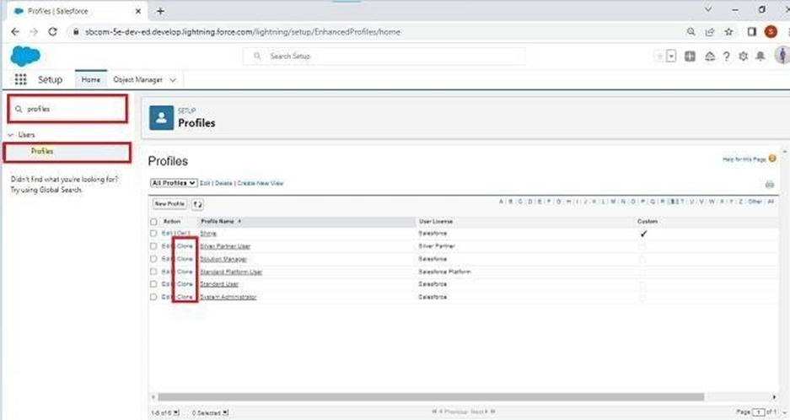

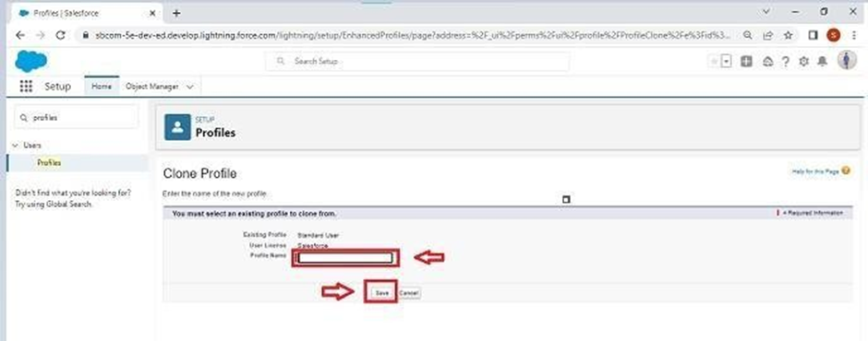

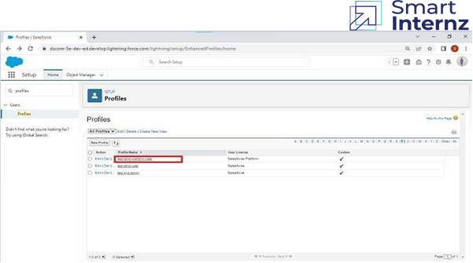

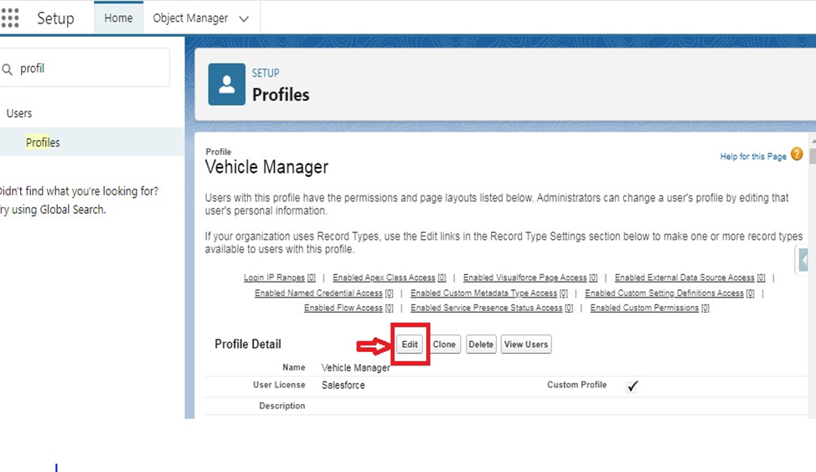

Scroll down to Custom Object Permissions and Give view all access permissions and assign to the parent profile.

**Setup Roles**

**Setup Roles:**

1.Click on the Gear Icon

2.Click "Setup"

3.In the Quick Find box, enter "Roles"

4.Click "Roles"

5.Click on "Set Up Roles"

6.Click "Expand All"

7.Under the CEO, click on "Add Role"

8.Fill up the Label as Vehicle Manager, Role Name Vehicle Manager.

9.Enter a Role name that will be displayed on Reports

10.Click on Save.

Similarly create Two Roles under Vehicle Manager as Operator 1 And Operator 2 Roles which will report to the Vehicle manager.

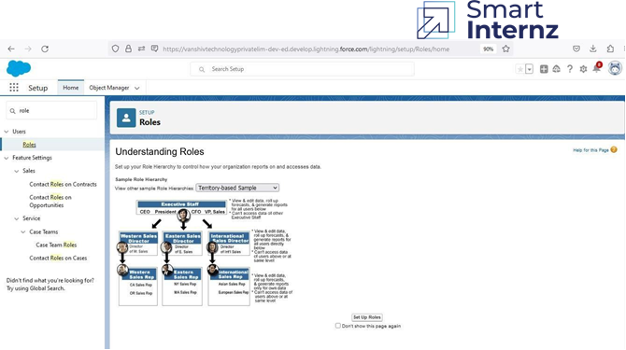

Click Add role under CEO

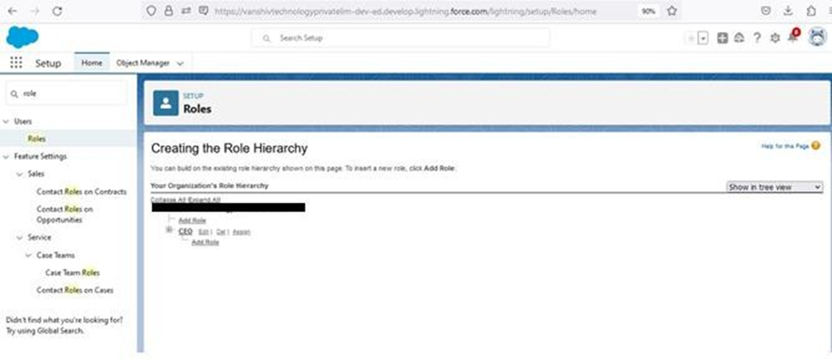

Enter Label name

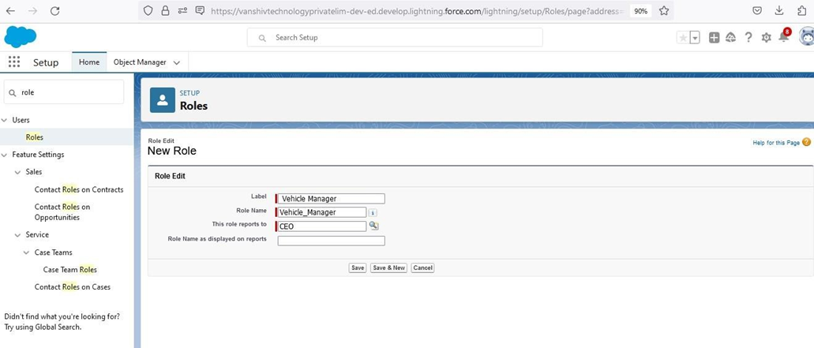

Click Add roll under Vehicle Manager

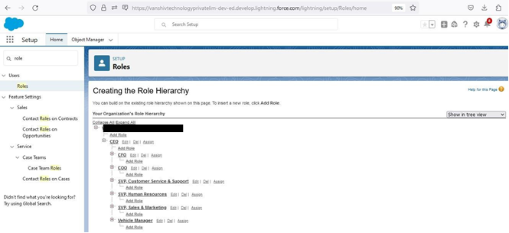

Enter Roll Label name

Click Save

**Users**

A user is anyone who logs in to Salesforce. Users are employees at your company, such as sales reps, managers, and IT specialists, who need access to the company's records. Every user in Salesforce has a user account.

**NOTE**- As Salesforce license can only be used by 2 Users at a time in Dev Org, so If you don’t find salesforce license then deactivate a user who has salesforce license Or change the license type from Salesforce to any other.

**Creating A User**

1.From Setup, in the Quick Find box, enter Users, and then select Users.

2.Click New User.

3.Enter the user’s name John Teddy and (Your) email address and a unique username in the form of an email address. By default, the username is the same as the email address.

4.Select a Role(Vehicle Manager)

5.Select a User License As salesforce.

6.Select a profile as Vehicle Manager.

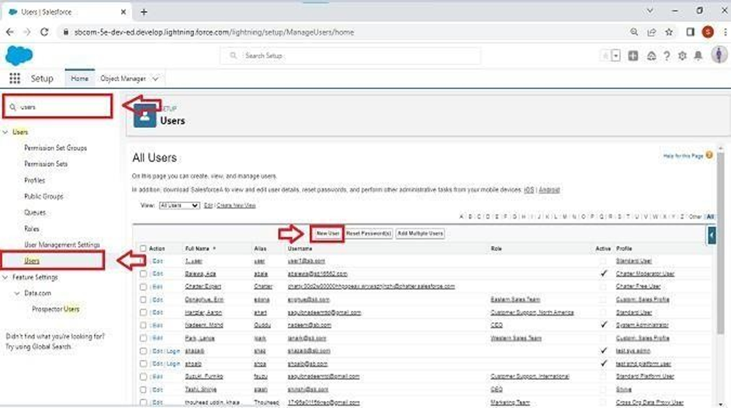

Fill in the fields (first name, last name, alias, email id, username, nick name, role, user license, profiles)

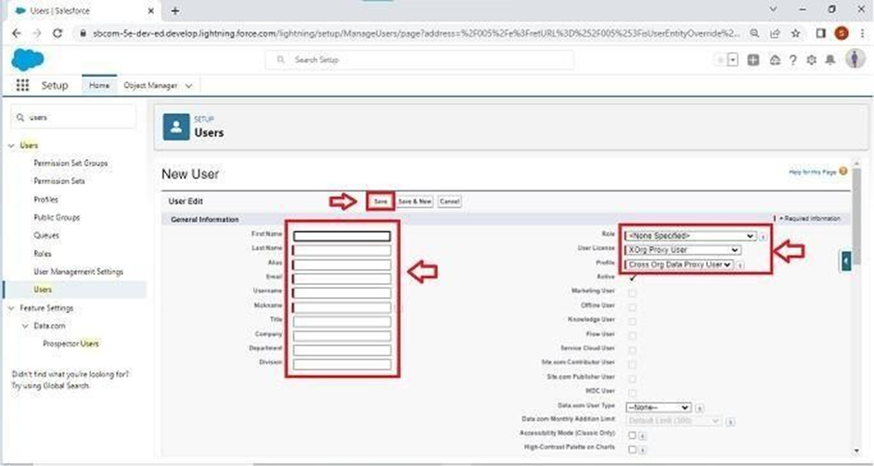

7.Check Generate new password and notify the user immediately to have the user’s login name and a temporary password emailed to your email.

8.Click On Save.

9.User will receive an email to reset password.

10.Once user will finish it, would be able to login and use the system.

Similarly Create other 2 users and assign operator 1 and operator 2 roles along with operator profile.

**User Adoption**

We need to understand user adoption and navigation. How to interact with database and their records.

### Create Vehicle Record

1.Click on App Launcher on left side of screen.

2.Search Vehicle Management System & click on it.

3.Click on Vehicle tab.

4.Click new button

5.Fill all Vehicle record details.

6.Click on Save Button

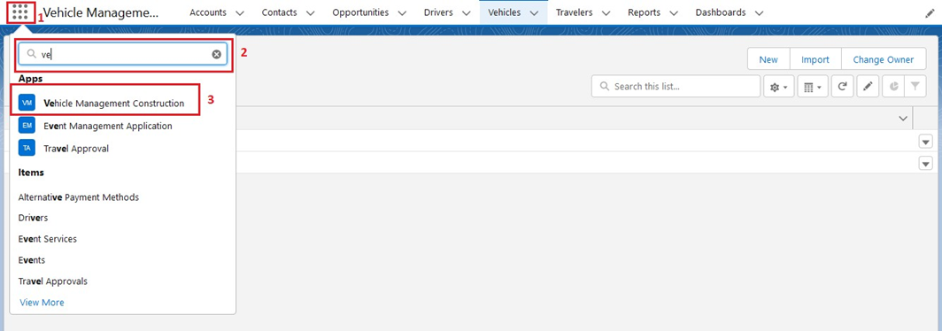

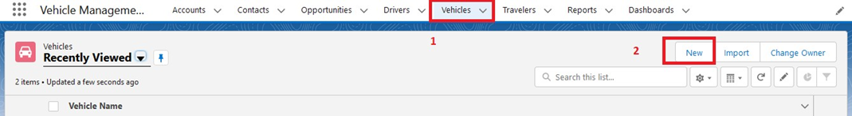

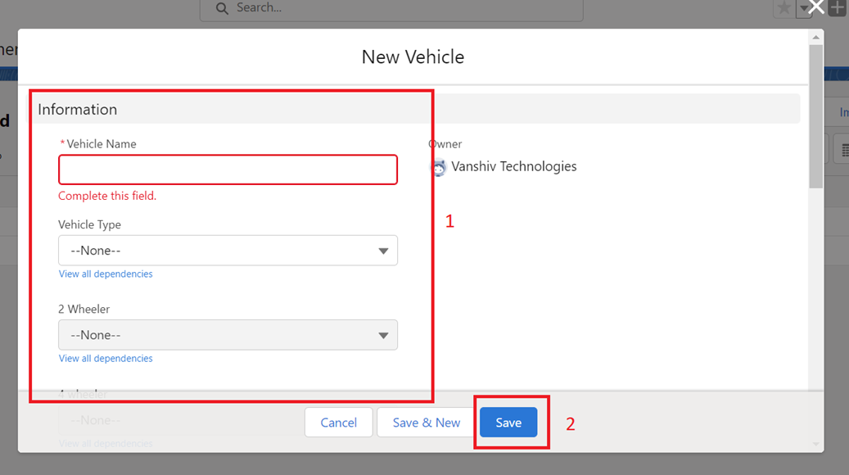

**View Record (Vehicle)**

1.Click on App Launcher on left side of screen.

2.Search Vehicle Management System & click on it.

3.Click on Vehicle Tab.

4.Click on any record name. you can see the details of the Vehicle

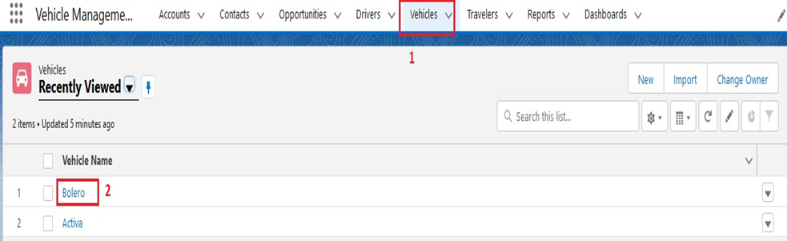

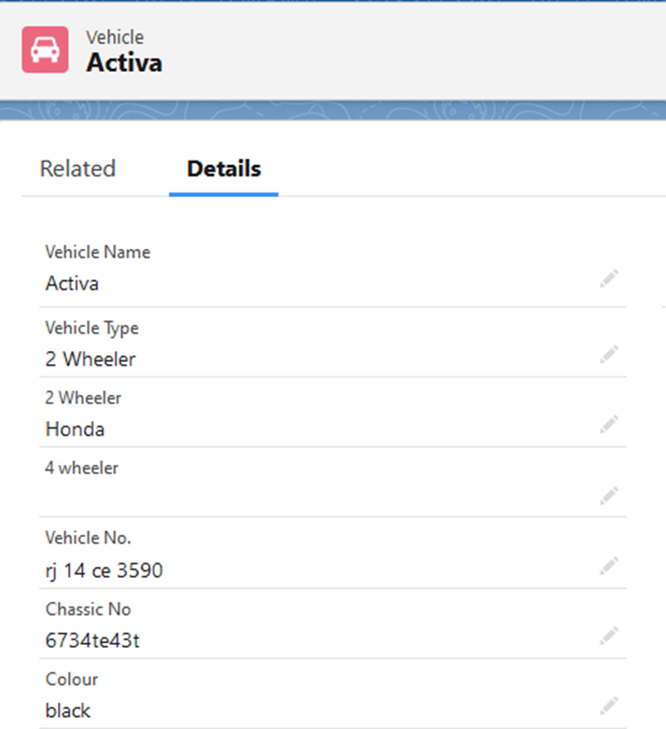

**Delete Record (Vehicle)**

1.Click on App Launcher on left side of screen.

2.Search Vehicle Management System & click on it.

3.Click on Vehicle Tab.

4.Click on Arrow at right hand side on that Particular record.

5.Click delete and delete again.

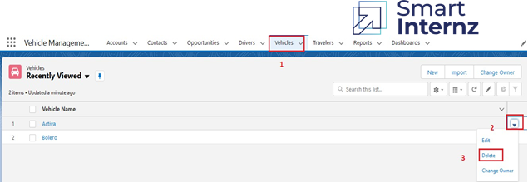

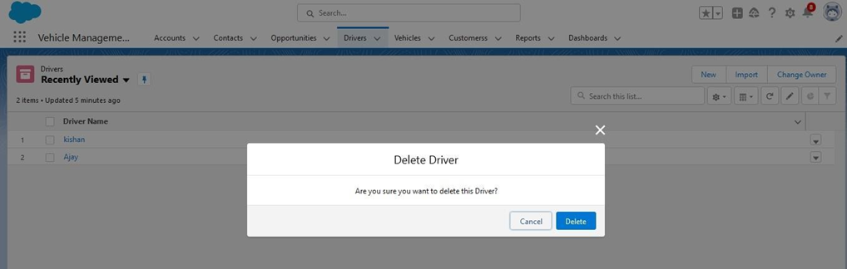

**Report & Dashboards**

A report is a list of records that meet the criteria you define. It's displayed in Salesforce in rows and columns, and can be filtered, grouped, or displayed in a graphical chart. Every report is stored in a folder. Folders can be public, hidden, or shared, and can be set to read-only or read/write.

**Report**

1.Click on App Launcher on left side of screen.

2.Search Vehicle Management System & click on it.

3.Click on Reports Tab.

4.Click on Opportunity Details report and see records

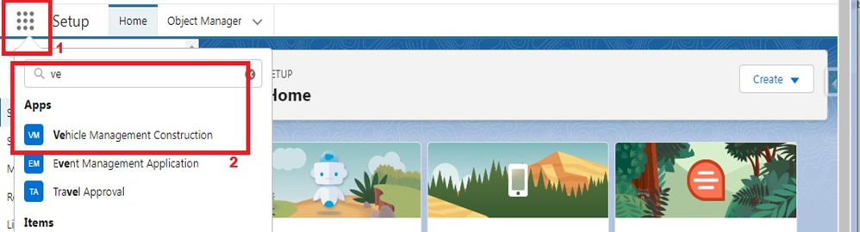

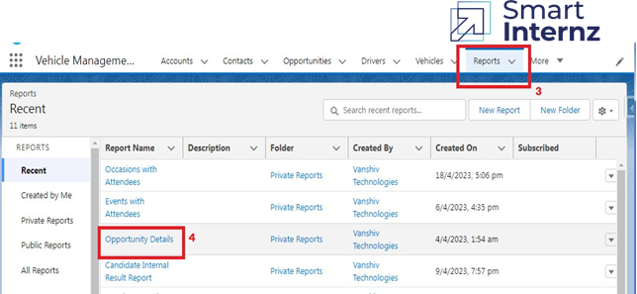

### Create Report

### 1. Go to Reports and click New Report.

### 2. Select the Opportunity and Traveller Name report type and click Start Report. (Under all categories)

### 3. To begin filtering, click Filters.

### 4. Click the Show Me standard filter and select All Travellers. Click Apply.

### 5.  Click on addcolumns add Opportunity: Opportunity name, Account Name, Amount, Traveller name etc.

### 6.  Reports needs to be Grouped by one field.(ex - Created by )(require to enable add chart)

### 7. Click Save.

### (Save your report as Opportunity Details and accept the auto-generated unique name).

### 

### 

### 

### 

8.  Click on App Launcher on left side of screen.

9.  Search Vehicle Management System & click on it.

10.  Click on Reports Tab.

11.   Click on Opportunity Details report and see records.

### 

### 

### Create Dashboard

1. Click the Dashboards tab.

2. Click New Dashboard.

3. Name the dashboard Opportunity Details and click Create.

4.Click +Component.

5. Select the Opportunity Details and click Select.

6. Select the Vertical Bar Chart component and click Add.

7. Click Save and then Done.

### 

### 

8.     Click on App Launcher on left side of screen.

9.     Search Vehicle Management System & click on it.

10.     Click on Dashboard Tab.

11.     Click on Opportunity and Dashboard and see graph view of records.

### 

### 